CENWP-OD-B 27 June 2023

MEMORANDUM FOR THE RECORD

SUBJECT: 23BON039 MFR WA Shore UMTJ RB2 Lamprey Mortality

On 27 June, Bonneville Fisheries discovered one adult Pacific Lamprey mortality in Rest Box 2 (UMTJ RB2) of the Washington Shore Lamprey Passage System. The fish was scanned for PIT tags, inspected, and returned to the river.

- Species – Pacific Lamprey (Entosphenus tridentatus)
- Origin – Unknown
- Length – 61.6 cm
- Marks and tags – None
- Marks and Injuries found on carcass – None
- Cause and Time of Death – Unknown
- Future and Preventative Measures – None

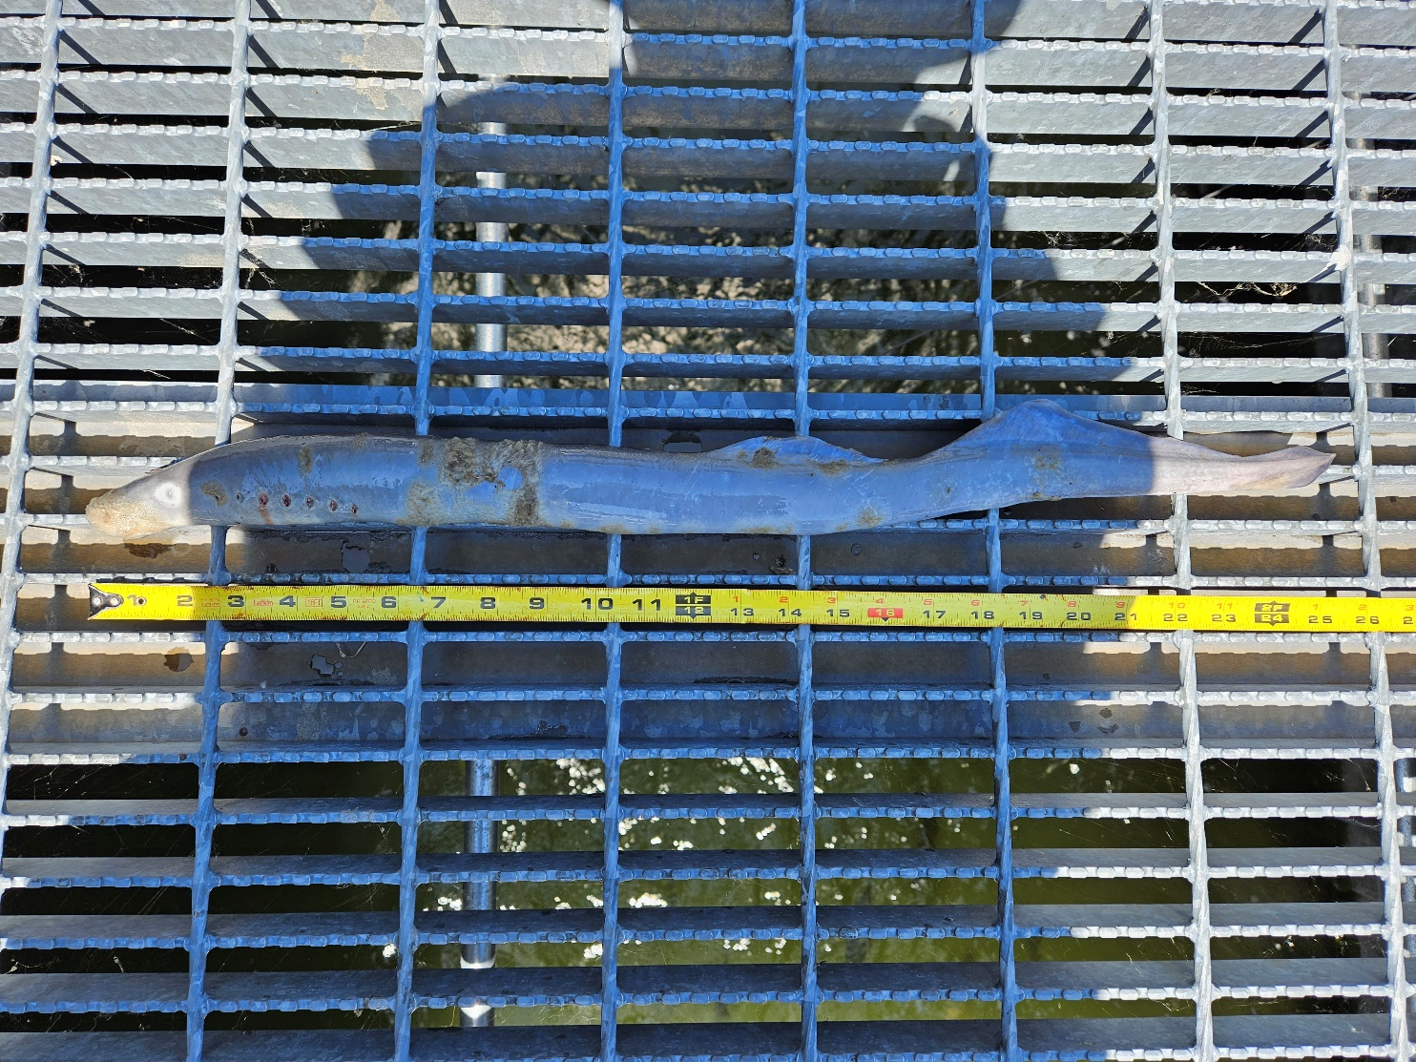

Sincerely,
Bonneville Project Fisheries

